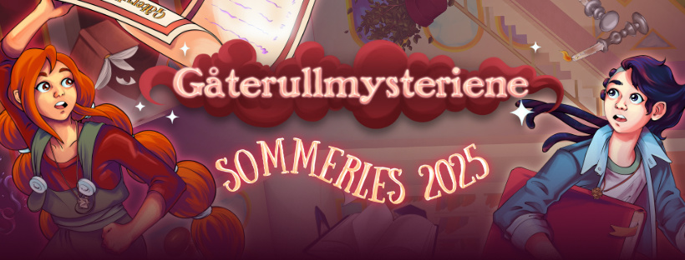

**TAKE PART IN THE COOLEST READING CAMPAIGN THIS SUMMER! 🚀**

**To Parents**

If you are in **1st to 7th grade** in school, from the **1st of June to the 31st of August**, you can take part in Sommerles.no!

Reading becomes fun and engaging with **Sommerles!** Create your profile at Sommerles.no, register the books you’ve read, see what books are popular, enjoy weekly challenges, and check out what your friends are reading. Read the epic story of Asbjørn and Astrid with a new chapter each week, written by Mari Moen Holsve. If you don’t have access to the internet, ask for a reading card at your local library to participate offline.

**Sommerles** is for all readers! Each book you register gives you XP (experience points) as you progress through the levels. You can read yourself, or get someone to read to you, and it doesn’t matter whether they are physical books, e-books, audiobooks, or comics – all reading counts. As you level up, you will receive prizes that you can collect at the library, as well as digital trophies that you can collect on your Sommerles profile.

To take part in Sommerles.no, visit the website on the 1st of June and create an account together with a parent/guardian. Parents/Guardians must give approval before you can participate and you must use a parent’s/guardian’s email address when registering. If you need any help, you can ask your local library for help.

**ENJOY YOUR SUMMER READING WITH SOMMERLES.NO**